COMSATS University Islamabad, Islamabad Campus



Secure Software Design and Development
Lab Final

Terraform and Vault (IAC)

Student Names | Muhammad Awais , Muhammad Umair Nazir , Muhammad Umar
Registration Numbers | SP23-BCT-008 , SP23-BCT-038 , SP23-BCT-040
Submission Date | 12 June 2026
Submitted To | Mr Muhammad Ahmed Nawaz
Install Terraform
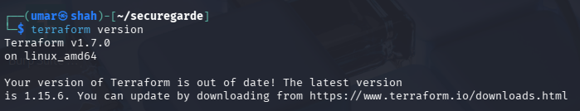
Providers.tf
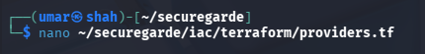
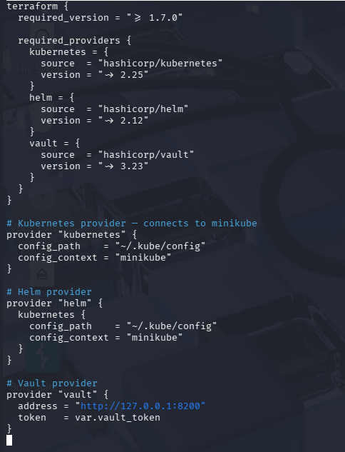
variables.tf
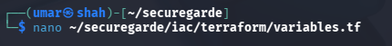
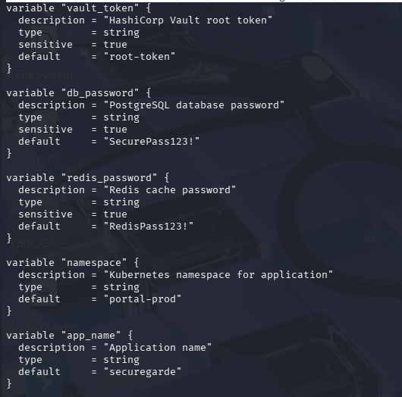
Install and run vault
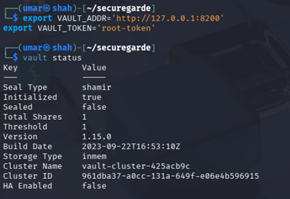
Initialize terraform
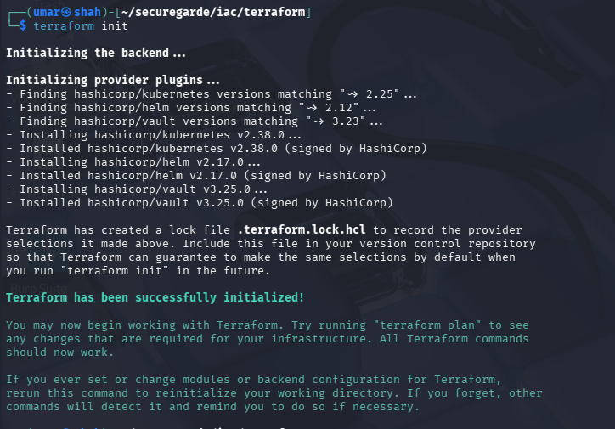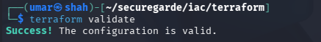

Terraform Plan
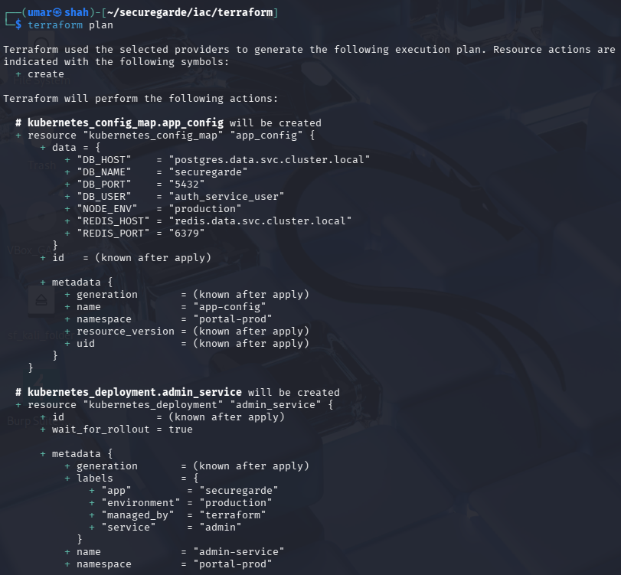
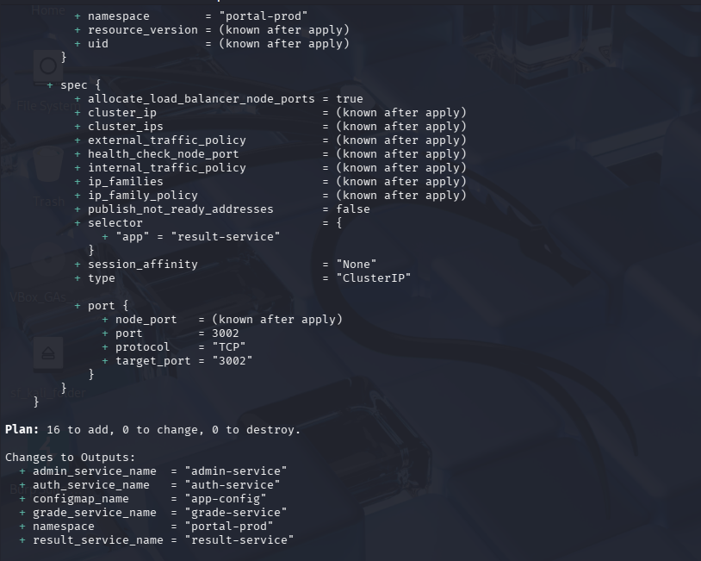
Save IaC reports
